Point of Sales

An example of UML [use case diagram](https://www.uml-diagrams.org/use-case-diagrams.html) for Point of Sale (POS) Terminal or Checkout. A retail POS system typically includes a computer, monitor, keyboard, barcode scanners, weight scale, receipt printer, credit card processing system, etc. and POS terminal software.

Checkout [use case](https://www.uml-diagrams.org/use-case.html) involves Customer, Clerk and Credit Payment Service [actors](https://www.uml-diagrams.org/use-case-actor.html) and [includes](https://www.uml-diagrams.org/use-case-include.html) scanning items, calculating total and taxes, payment use cases.

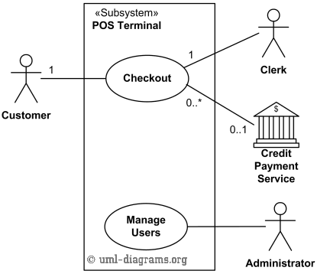

Top level UML use cases for Point of Sales Terminal (POS).

Checkout use case requires Customer actor, hence the 1 multiplicity of Customer. Clerk can only participate in a single Checkout use case. Credit Payment Service can participate with many Checkout use cases at the same time. Checkout use case may not need Credit Payment Service (for example, if payment is in cash), thus the 0..1 multiplicity.

Checkout use case is an example of a large and complex use case split into several use cases each describing some logical unit of behavior. Note, that including use case becomes incomplete by itself and requires the included use cases to be complete.

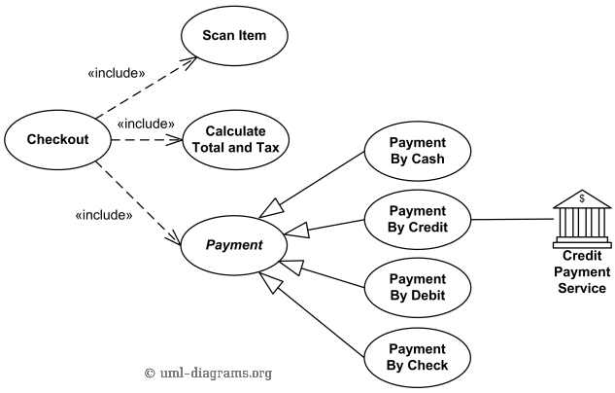

Checkout use case includes Scan Item, Calculate Total and Tax, and Payment use cases.

Payment use case is represented using [generalization](https://www.uml-diagrams.org/generalization.html) relationship. It means that only one specific type of payment is accepted - either by cash, or by credit, debit, or with check. An alternative to such representation could be to use [include](https://www.uml-diagrams.org/use-case-include.html) relationship so that not just single but several forms of payment could be accepted from the same client during checkout.